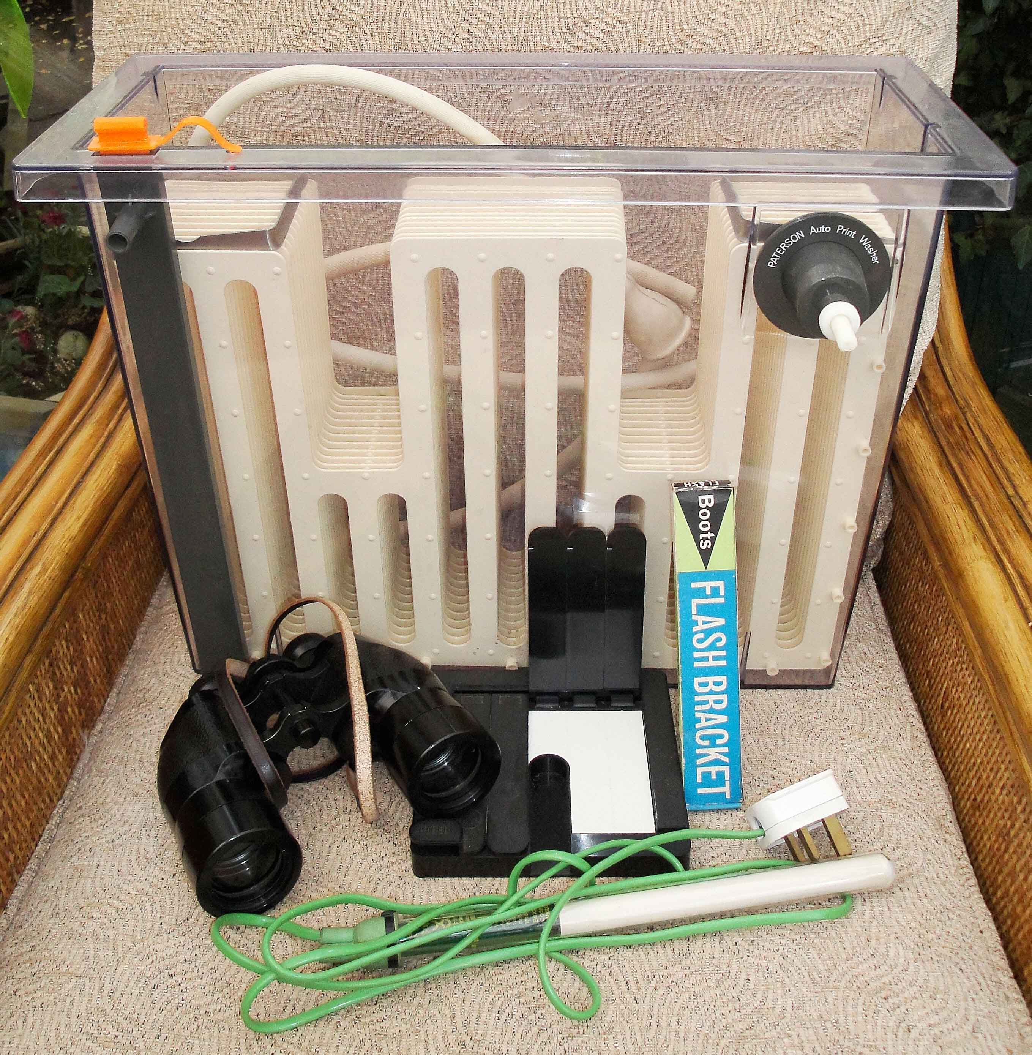

In the 'photo there is a Paterson "rocking" print washer. Note this is the rare full 16x12" model, NOT the more common 11x9.5" - I don't think it's ever been wet a test-strip printer, a tray (or pond/aquarium) heater, a flash bar and a pair of superb Ross (London) "Solaross" 12x40 binos. These are ideal for bird-watching, astronomy etc. I'm not sure they've ever been used, the glass is extremely clean, as is the leather case. Also there is a small back-projection screen, two Braun projector carousels (new, boxed), a Canon chestpod, several monopods, and a selection of tripods from large studio type, through medium, to small travel jobs. All these items are in super condition. I'm looking for £15 for the print washer, and £20 for the binos. The rest will be open to generous offers. If you definitely want one of these things, please contact me ASAP and I will reserve it for you

